Pastoral Coordinator
Thank you for your interest in this post.
It is an exciting time to join us. We are looking for the right person to help develop pastoral provision at the school and support our pupils curriculum across our small rural academy set in the Yorkshire Dales National Park.
Settlebeck School is a fantastic place to work and we hope that this pack will provide you with the information you need about the advertised post as well as give you a flavour of our school.
+
Role | Pastoral Coordinator, 37 hour per week, term time+ 1 week
Pay | NJC Scale 5 12-17 £26,421-£28,770 (pro-rata)
Deadline | Tuesday 9 May 2023 at 12 Noon
Visit (optional) | On request
Interviews | w/c 22 May 2023

Contents
1.. Introduction
. 2.. Our Context
. 3.. Our Environment
. 4.. Our Values
. 5 . The Post: Job Description
. 6.. The Post: Person Specification

1 | Introduction

People say Settlebeck School is a special place and we believe this is seen in the warmth of relationships, the ‘family feel’ ethos where each student is treated as an individual, high expectations and achievement for all.  We seek a passionate and dynamic individual to support our students.  In return, we can offer you an opportunity to join a community with ambition; this is a truly wonderful place to work.  We appreciate there is much in addition that you would want to know and, therefore, encourage you to get more of a ‘feel’ for the life of our school by visiting our website;  www.settlebeck.org  If you would like arrange a visit prior to application, please contact Louise Metcalfe, PA to the Headteacher metcalfel@settlebeck.org /015396 20383  If there is anything specific you wish to know at this stage, please don’t hesitate to get in touch. | 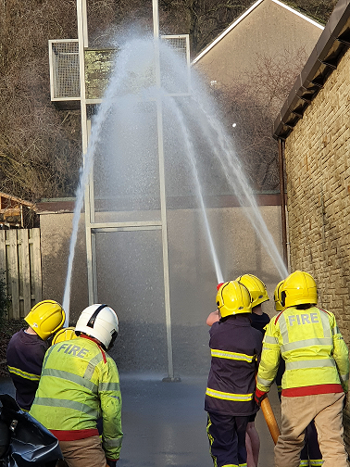
. 2.. Our Context

Settlebeck School has been proudly serving Sedbergh and the surrounding area for over 70 years and is at the heart of its community.  The school also benefits from wide-ranging links and partnerships within the Cumbrian educational community and particularly the South Lakes Federation, which is a long-established federation of 10 secondary schools, Kendal College and the University of Cumbria.  We have a truly comprehensive intake with 208 students, 11-16, currently on roll. As a strategically resourced provision for young people with autism, the successful candidate must be fully committed to inclusion. Visitors are always impressed by our family atmosphere, the warmth of relationships between staff and students and value for the individual.  We are committed to providing high quality teaching and learning, a broad and balanced curriculum, focused on the needs of the individual, and a truly inclusive provision which is underpinned by our core values. | 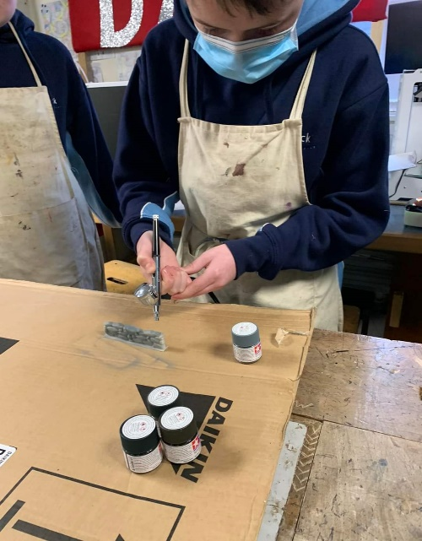  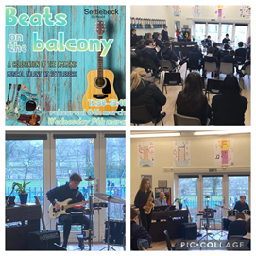

. 3.. Our Environment

Settlebeck School is situated in the beautiful market town of Sedbergh, which borders the Lake District and Yorkshire Dales National Park.

We serve a prosperous and beautiful area of South Lakeland and North Yorkshire, with students drawn from as far away as Hawes, Askrigg, Kirkby Stephen, Kendal and Lancaster, as well as those living in and local to Sedbergh. Although rural, we are only 5 miles from the M6.

Since 2017, the school has undergone a number of successful refurbishment projects to upgrade its facilities and this, alongside the extensive outdoor spaces with views of the surrounding fells, makes it a lovely place to learn.

Someone coming to work here, as well as enjoying the advantages of the natural environment, can expect the opportunity to encounter pleasant, amenable, motivated students and friendly, supportive colleagues. You will be given every opportunity to pursue professional development, while being encouraged to perform to the highest standards. Staff well-being is high priority for the leadership of the school.

. 4.. Our Values
We aim to achieve our vision ‘Achievement for all – transforming lives through learning’ by supporting the development of our young people so that they come happy, confident individuals who can make a positive contribution to society and become the best versions of themselves.  Our core values of respect, responsibility and aspiration underpin and inform all aspects of school life.  Whether speaking to parents at an Open Evening, helping a young person make decisions about their future or appointing staff, our values are at the core.  Our students contribute to the daily life of the school and help shape our practice and live our values through the student leadership team, student council and house system.  Staff well-being is a high priority as we believe that a happy workforce who feel supported and respected is the key to a successful school. | 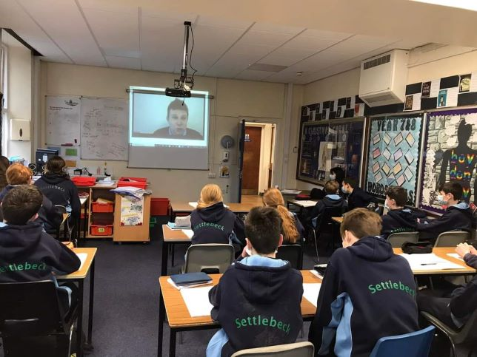

. 5 . The Post: Job Description
Post Title: Pastoral Coordinator
Contract | 37 hour per week, term time + one week
Salary | NJC
Responsible to | Headteacher
Start Date | As soon as possible
Core Purpose
To pastorally support our pupils in Year 7-11 to ensure that they have every opportunity to thrive. The post holder will carry our five primary functions:
- General pastoral support for students in Years 7 to 11;
- Monitoring and intervention for students with attendance issues;
- Monitoring and intervention for Pupil Premium Students;
- General intervention support for students underachieving in more than one subject area or with behavioural issues. Note this will not require the post holder to have specific subject knowledge rather to support students to develop the generic skills required to be successful in school; i.e. personal organisation, time management, prioritising, social and interpersonal skills etc;
- To communicate effectively with all professionals, both internal and external.
Attendance
- Monitor students’ attendance and punctuality.
- Where necessary / appropriate make home visits with another colleague to address attendance and other issues or where parents find it difficult to get in to school.
- Act as first point of reference for issues relating to student absence, welfare and behaviour.
- Respond promptly to parental concerns and refer more serious parental concerns to the Leadership Team as appropriate.
- Support progression through the attendance policy liaising with internal colleagues and external agencies.
Pastoral Care and Student Support
- Establish productive and effective working relationships with students, acting as a role model and setting high standards for behaviour.
- Act as the first point of contact for students on a daily basis to resolve any issues they may have.
- To work with students to promote positive attitudes, emotional regulation and positive behaviour in line with the school’s behaviour policy.
- Review and investigate incidents that occur in and out of school, ensuring that accurate records are kept and stored appropriately.
- Ensure that all behaviour concerns are communicated effectively to students, parents and staff.
- Intervene with students requiring support to help develop generic strategies and skills required for success in secondary education.
- Liaise with other professionals and external agencies as required.
- To open and run Early Help Assessments to facilitate progress and review pastoral.
- Follow the school safeguarding protocols, reporting any concerns to the DSL and supporting with the collation and dissemination of relevant information.
- Where necessary, supervise the SOS room, ensuring that teaching staff provide support for them.
- Provide regular feedback to parents/carers and student in relation to progress, achievement, behaviour, attendance and other key issues.
- Promote and positively contribute to the House System.
- Update staff following any concerns/issues in a timely manner.
- Contribute to the preparation and implementation of individual student risk assessments/behaviour management plans.
- Support colleagues with behaviour issues/welfare issues.
- Identify strategies to support students to overcome barriers to learning.
- If appropriate, develop and implement an intervention programme to address the behavioural, social and emotional needs to individuals and small groups.
- Support new students to Settlebeck School and in-year admissions.
- Organise work for students who have been suspended or isolated.
- Be available as required, to provide first aid for students and colleagues as part of team of first aiders.
Administrative Duties
- Provide pastoral support for Parents’ Evenings, Information Evenings and Open Evenings as required.
- Review daily, weekly and cumulative behaviour and achievement data in order to monitor and anaylse patterns across the school and support appropriate actions to address those trends on an individual and small group basis.
- Communicate daily and weekly with parents in relation to concerns.
- Support the whole school behaviour staged response system.
- Attend and provide input into suspension meetings with parents/carers and students as required.
- Utilise local authority strategies (Early Help/Child in Need), in order to draw upon other agency support for students and their families.
- Maintain accurate and complete student records.
- Signpost parents/carers to support available to them.

Support for the School
- Comply with the policies and procedures relating to child protection, health and safety, security, code of conduct, confidentiality and data protection, reporting all concerns to the appropriate person.
- Be aware of and support difference, ensuring all students have equitable access to opportunities to learn and develop.
- Contribute to the overall ethos/work/aims of the school.
- Participate in professional development training as required.
- Assist with the supervision of students outside of lesson times, including before and after school, break and lunchtime.
- Act as a professional and positive ambassador for the school in order to support the school’s mission and profile.
- Ensure confidentiality of the school’s activities is maintained in order to protect the integrity of the organisation and its people.

6.. The Post: Person Specification
Criteria | Essential | Desirable | Method of assessment
Education and Qualifications
English and Maths to GCSE grade 4/C or above or the equivalent e.g Functional Skills Level 2 | √ |  | Application/Interview
Relevant qualifications working with young people |  | √ | Application/Interview
Willingness to obtain First Aid certificate and undertake Mental Health First Aid training | √ |  | Application/Interview
Hold current valid Emergency First Aid at Work/First Aid at Work certificate |  | √ | Application/Interview
Qualification in education, youth work or counselling |  | √ | Application/Interview
Experience
Experience of working with children/young people | √ |  | Application  Interview  Reference
Work experience in school/education settings | √ |  | Application  Interview  Reference
Knowledge, understanding and experience of child protection and wider safeguarding remit | √ |  | Application  Interview  Reference
Experience and evidence of impact working with external agencies |  | √ | Application  Interview  Reference
High expectations | √ |  | Application  Interview  Reference
Partnership working and collaboration | √ |  | Application  Interview  Reference
Evidence of impact upon outcomes in working with children /young people in pastoral settings |  | √ | Application  Interview  Reference
Experience of engagement of young people/children to improve outcomes |  | √ | Application  Interview  Reference
Professional skills and attributes
The ability to learn quickly, assimilate ideas, generate understanding, be challenged and be flexible | √ |  | Interview
The ability to be able to support policies and systems | √ |  | Interview
High level communication skills, including an understanding of the need, and the skills to build relationships and to keep people informed | √ |  | Interview
The ability to prioritise work, manage time effectively, work without supervision and meet deadlines | √ |  | Interview
Willingness to undertake further training as required and maintain a high level of up to date knowledge | √ |  | Interview
The ability to be creative, flexible and adaptable to the changing demands of the post | √ |  | Interview
Excellent IT skills including a good level of competence in Microsoft Office and the ability to quickly become familiar with the school’s Management Information System | √ |  | Interview
Personal qualities
Integrity, honesty and consistency of approach and a respect for others | √ |  | Interview
Be able to lead by example | √ |  | Interview
Stamina to cope with the demands of the job | √ |  | Interview

If you require further information or wish to discuss any issues, please do get in touch with Louise Metcalfe, PA to the Headteacher
015396 20383
office@settlebeck.org

www.settlebeck.org
Twitter: @SettlebeckS
Facebook: Settlebeck School

