Teacher of Art
Thank you for your interest in this post.
It is an exciting time to join us. We are looking for the right person who can help develop the Art curriculum across our small rural academy set in the Yorkshire Dales National Park.
Settlebeck School is a fantastic place to work and we hope that this pack will provide you with the information you need about the advertised post as well as give you a flavour of our school.

Role | Teacher of Art 0.4 FTE Permanent
Pay | MPS/UPS
Deadline | Tuesday 23rd May at 4pm
Visit (optional) | On request
Interviews | Friday 26th May 2023

Contents
1.. Introduction
. 2.. Our Context
. 3.. Our Environment
. 4.. Our Values
. 5 . The Post: Job Description
. 6.. The Post: Person Specification

1 | Introduction

People say Settlebeck School is a special place and we believe this is seen in the warmth of relationships, the ‘family feel’ ethos where each student is treated as an individual, high expectations and achievement for all.  We seek a passionate and dynamic teacher, who is committed to inclusion, to join our Art Department.  In return, we can offer you an opportunity to join a community with ambition; this is a truly wonderful place to teach. We would welcome applications from candidates who are committed to inclusion and ensuring that all pupils achieve their potential, whether an ECT, MPS or UPS teacher. If a candidate can offer a second subject, there is the potential for an increase in contracted hours.  We appreciate there is much in addition that you would want to know and, therefore, encourage you to get more of a ‘feel’ for the life of our school by visiting our website;  www.settlebeck.org  If you would like arrange a visit prior to application, please contact Louise Metcalfe, PA to the Headteacher metcalfel@settlebeck.org /015396 20383  If there is anything specific you wish to know at this stage, please don’t hesitate to get in touch. | 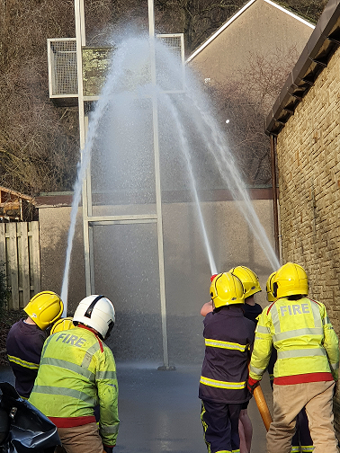
. 2.. Our Context

Settlebeck School has been proudly serving Sedbergh and the surrounding area for over 70 years and is at the heart of its community.  The school also benefits from wide-ranging links and partnerships within the Cumbrian educational community and particularly the South Lakes Federation, which is a long-established federation of 10 secondary schools, Kendal College and the University of Cumbria.  We have a truly comprehensive intake with 208 students, 11-16, currently on roll. As a strategically resourced provision for young people with autism, the successful candidate must be fully committed to inclusion. Visitors are always impressed by our family atmosphere, the warmth of relationships between staff and students and value for the individual.  We are committed to providing high quality teaching and learning, a broad and balanced curriculum, focused on the needs of the individual, and a truly inclusive provision which is underpinned by our core values. | 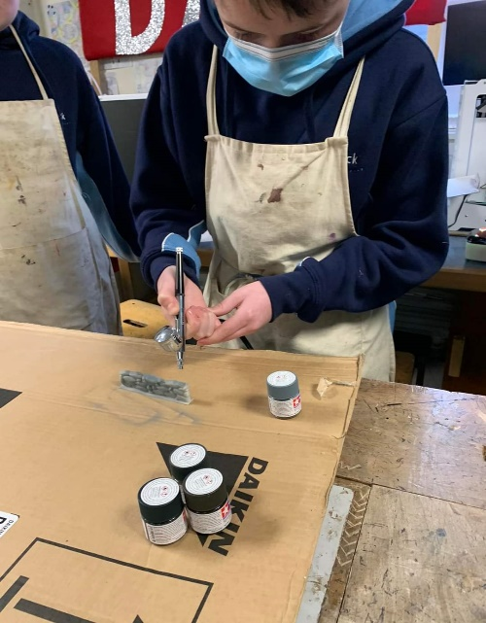  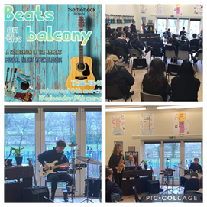

. 3.. Our Environment

Settlebeck School is situated in the beautiful market town of Sedbergh, which borders the Lake District and Yorkshire Dales National Park.

We serve a prosperous and beautiful area of South Lakeland and North Yorkshire, with students drawn from as far away as Hawes, Askrigg, Kirkby Stephen, Kendal and Lancaster, as well as those living in and local to Sedbergh. Although rural, we are only 5 miles from the M6.

Since 2017, the school has undergone a number of successful refurbishment projects to upgrade its facilities and this, alongside the extensive outdoor spaces with views of the surrounding fells, makes it a lovely place to learn.

Someone coming to work here, as well as enjoying the advantages of the natural environment, can expect the opportunity to encounter pleasant, amenable, motivated students and friendly, supportive colleagues. You will be given every opportunity to pursue professional development, while being encouraged to perform to the highest standards. Staff well-being is high priority for the leadership of the school.

. 4.. Our Values
We aim to achieve our vision ‘Achievement for all – transforming lives through learning’ by supporting the development of our young people so that they come happy, confident individuals who can make a positive contribution to society and become the best versions of themselves.  Our core values of respect, responsibility and aspiration underpin and inform all aspects of school life.  Whether speaking to parents at an Open Evening, helping a young person make decisions about their future or appointing staff, our values are at the core.  Our students contribute to the daily life of the school and help shape our practice and live our values through the student leadership team, student council and house system.  Staff well-being is a high priority as we believe that a happy workforce who feel supported and respected is the key to a successful school. | 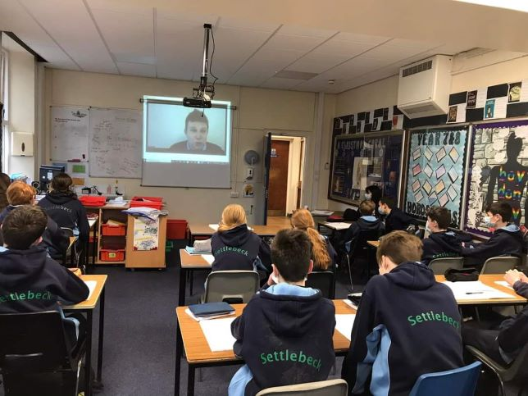

. 5 . The Post: Job Description
Post Title: Teacher of Art
Contract | 0.4 FTE Permanent
Salary | MPS/UPS
Responsible to | Headteacher
Start Date | September 2023
Core Purpose
A teacher’s responsibilities at Settlebeck School are those set out in the Schoolteachers’ Pay and Conditions document, including any other reasonable duties requested by the Headteacher and in line with agreed national and school policies. Reference has also been made to the National Standards for Qualified Teacher Status published and any revisions to these which are made from time to time in discussion with the professional associations.

Teaching and Learning/Curriculum
- Planning and preparing courses and lessons in line with the Learning & Teaching Policy: -
  - with differentiation according to age and ability and, where appropriate, special educational need
  - with learning sequenced to build on prior learning
  - which challenge and stretch learners to achieve the very best outcomes
- Assessing, recording and reporting on the development, progress and attainment of students (including monitoring student progress against academic potential and appropriate targets), having due regard for the Assessment for Learning policy.
- Implementing the school’s behaviour policy, rewards and sanctions.
- Acting as a Form Tutor or being attached to a year group (see generic Form Tutor job description below) and playing a part in ensuring the successful development of the school’s tutoring programme.
- Participating in the development of the personal development curriculum.
- Contributing to students’ Spiritual, Moral, Social and Cultural development in line with school policy.
- Communicating and consulting with parents as required.
- Awareness of the potential of each student, monitoring progress against potential and taking action to enable students achieve that potential.
- Acting as a role model in terms of attitude, dress (including adhering to the school dress code for teaching & non-teaching staff) and interaction with others.
- Contribute to the development and delivery of a coherent, well-sequenced curriculum which ensures the maximum progress for all students across the ability range, builds on the foundations of the primary curriculum and builds the knowledge and skills for students to progress into their chosen career pathway.

Other main responsibilities
- Maintain high expectations for yourself and student behaviour at all times.
- Ensure that safeguarding is given a high priority at all times.
- To be involved in annual appraisal arrangements as determined by the current school teachers’ pay and conditions document and school policy.
- To undertake an annual identification of professional development and training requirements with a line manager as part of the appraisal process.
- To engage in regular review of learning and teaching and of schemes of learning.

Discipline, Health and Safety

- Maintain good order and discipline among the students and safeguard their health and safety, both when they are authorised to be on the school premises and when they are engaged in authorised school activities elsewhere.
- To support the school uniform policy and ensure students are correctly dressed at all times.
- To take a register in a timely manner each lesson.

Meetings and Directed Time

- To participate in all directed time activities as identified by the calendar and the duty rota.

Specific Form Tutor Responsibilities

Care Guidance and Support

- To be the primary point of contact between parents and the school.
- To take a keen interest in the academic and personal development and well-being of students within the form.
- To support the school policy on uniform and to ensure students are correctly dressed at all times.
- To liaise as necessary with Progress Leaders, subject teachers, SENCO and parents.
- To take part in the monitoring process for students causing concern in line with the Behaviour Management Policy.
- To deliver the taught element of the tutorial programme.
- To act as a role model and mentor.
- To produce annually a summative report on students’ progress as part of the school reporting system.
- To monitor and sign student planners, supporting their use by students as an organisational tool.
- To be aware of the targets and special needs of students within the form and to play a part in helping them to meet those targets.

Administration

- To ensure that morning registration procedures are correctly administered.
- To be a first check on monitoring of progress, attendance, punctuality and behaviour.

6.. The Post: Person Specification
Criteria | Essential | Desirable | Method of assessment
Education and Qualifications
Strong degree | √ |  | Application/Interview
Qualified teacher status | √ |  | Application/Interview
Successful teaching experience across a range of student abilities and key stages | √
Further relevant qualifications |  | √
Experience
Successful relevant teaching experience across a range of student abilities within secondary schools | √ |  | Application  Interview  Reference
Highly effective classroom teacher, whose practice inspires and develops others | √ |  | Application  Interview  Reference
Experience of working with secondary age students 11-16 across the ability range | √ |  | Application  Interview  Reference
Experience and impact of delivering Art | √ |  | Application  Interview  Reference
Professional skills and attributes
A breadth of interest beyond the school curriculum |  | √ | Interview
A commitment of own learning | √ |  | Interview
A commitment to comprehensive education | √ |  | Interview
A commitment to inclusion | √ |  | Interview
Good knowledge of what makes effective teaching and learning | √ |  | Interview
Good knowledge of recent educational developments |  | √ | Interview
The ability to motivate students, set high expectations which inspire, motivate and challenge | √ |  | Interview
The ability to effective manage behaviour to ensure a safe environment | √ |  | Interview
Be able to work as part of a team | √ |  | Interview
Be able to form and maintain professional relationships | √ |  | Interview
Personal qualities
Integrity, honesty and consistency of approach and a respect for others | √ |  | Interview
Be able to lead by example | √ |  | Interview
Stamina to cope with the demands of the job | √ |  | Interview

If you require further information or wish to discuss any issues, please do get in touch with Louise Metcalfe, PA to the Headteacher
015396 20383
office@settlebeck.org

www.settlebeck.org
Twitter: @SettlebeckS
Facebook: Settlebeck School

